Lab1 Report

Part 1

1(a)

Round 1

Marks:60/100

MSE是錯的

This one:

X1 = , X2 = , X3 = , X4 =

C1 = , C2 =

X1 = and C1 = , d = 2

X1 = and C2 = , d =

X1 belongs to group 1.

X2 = and C1 = , d = 1

X2 = and C2 = , d =

X2 belongs to group 1.

X3 = and C1 = , d = 0

X3 = and C2 = , d =

X3 belongs to group 1.

X4 = and C1 = , d =

X4 = and C2 = , d = 0

X4 belongs to group 2.

C1 = = =

C2 = X4 =

Round 2

X1 = , X2 = , X3 = , X4 =

C1 = , C2 =

X1 = and C1 = , d = 1

X1 = and C2 = , d =

X1 belongs to group 1.

X2 = and C1 = , d = 0

X2 = and C2 = , d =

X2 belongs to group 1.

X3 = and C1 = , d = 1

X3 = and C2 = , d =

X3 belongs to group 1.

X4 = and C1 = , d =

X4 = and C2 = , d = 0

X4 belongs to group 2.

Therefore no change.

MSE = $\frac{9}{4}$

1(b)

Round1

X1 = , X2 = , X3 = , X4 =

C1 = , C2 =

X1 = and C1 = , d = 0

X1 = and C2 = , d = 1

X1 belongs to group 1.

X2 = and C1 = , d = 1

X2 = and C2 = , d = 0

X2 belongs to group 2.

X3 = and C1 = , d = 2

X3 = and C2 = , d = 1

X3 belongs to group 2.

X4 = and C1 = , d =

X4 = and C2 = , d =

X4 belongs to group 2.

C1 =

C2 = = =

Round 2

X1 = , X2 = , X3 = , X4 =

C1 = , C2 =

X1 = and C1 = , d = 0

X1 = and C2 = , d =

X1 belongs to group 1.

X2 = and C1 = , d = 1

X2 = and C2 = , d =

X2 belongs to group 1.

X3 = and C1 = , d = 2

X3 = and C2 = , d =

X3 belongs to group 2.

X4 = and C1 = , d =

X4 = and C2 = , d =

X4 belongs to group 2.

C1 = = =

C2 = = =

Round 3

X1 = , X2 = , X3 = , X4 =

C1 = , C2 =

X1 = and C1 = , d =

X1 = and C2 = , d =

X1 belongs to group 1.

X2 = and C1 = , d =

X2 = and C2 = , d =

X2 belongs to group 1.

X3 = and C1 = , d =

X3 = and C2 = , d =

X3 belongs to group 2.

X4 = and C1 = , d =

X4 = and C2 = , d =

X4 belongs to group 2.

Therefore no update.

MSE = $\frac{3}{2}$

1(c) As 1(b) MSE is smaller than 1(a) MSE

Smaller MSE means more accurate.

Q2

$\frac{512 x 512}{16 x 1}$ = 32

Because 512/16 = 32

Q3

Because computer system use binary system for data storage and computing.

Q4

It is not good to increase the value of k to 2048.

This program is to compress the file size of the photo, but 2048 is larger then 512, that means the file sizes will much larger.

Part 2

Fruit Mse:

256 : 6.942656226925197e-04

128 : 9.490993664949592e-04

64 : 0.001264119962350

32 : 0.001682274935611

16 : 0.002413811461636

Baboon Mse:

256 : 0.003513663533229

128 : 0.004074078604252

64 : 0.004755476155501

32 : 0.005522967256663

16: 0.006483011997849

MSE:

|  |  |  |  |  |  |
| --- | --- | --- | --- | --- | --- |
|  | K=256 | K=128 | K=64 | K=32 | K=16 |
| Fruit | $≈$ 6.94x10-4 | 9.49x10-4 | 0.00126 | $≈$ 0.00168 | $≈$ 0.00241 |
| Baboon | $≈$ 0.00351 | $≈$ 0.00407 | $≈$ 0.00476 | $≈$ 0.00552 | $≈$ 0.00648 |

Original Image:

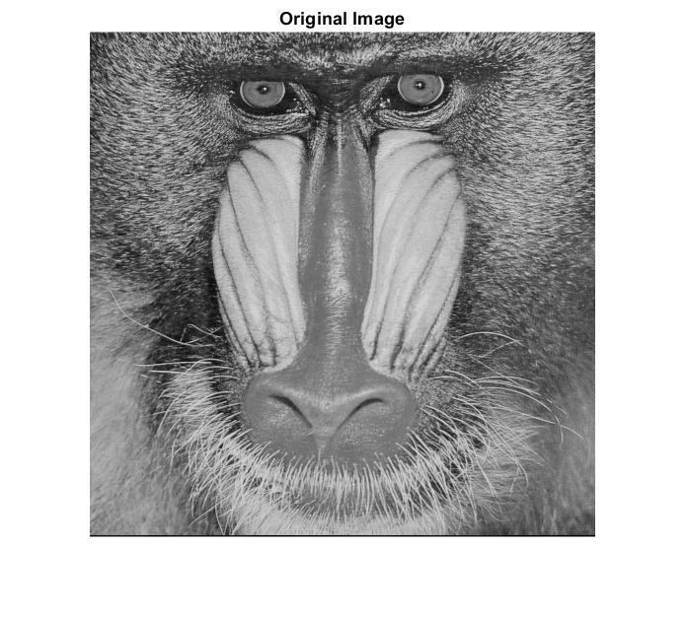Fruit Baboon

K = 256:

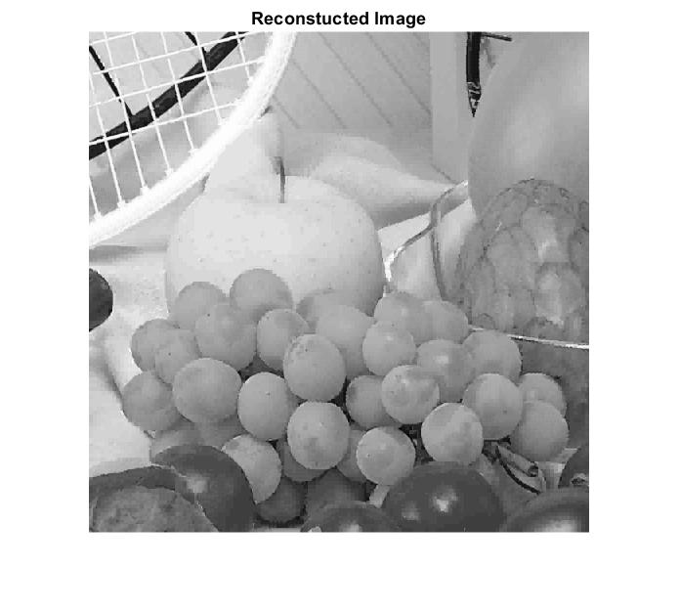Fruit Baboon

K = 128:

Fruit Baboon

K = 64

Fruit Baboon

K = 32

Fruit Baboon

K = 16

Fruit Baboon

Observation:

When the value of k is smaller, MSE value will become larger, but the increase of k and MSE is not in same variation. When K is smaller, it’s storage requirement and visual quality will also lower, i.e smaller file size and worser image quality.

File size:

|  |  |  |  |  |  |  |
| --- | --- | --- | --- | --- | --- | --- |
|  | original | K=256 | K=128 | K=64 | K=32 | K=16 |
| fruits | 42KB | 39KB | 39KB | 38KB | 37KB | 37KB |
| baboon | 75KB | 67KB | 64KB | 63KB | 60KB | 57KB |

Image quality:

Can be found in upside.